**MVVM (Model-View-ViewModel) architecture**

1. **Model** is used to write Business logic. The model represents the actual data the application is dealing with. It is not tied to the view which makes it reusable.
2. **View** is used to observe data from ViewModel and inform ViewModel of user interaction.
3. **ViewModel**  is responsible for processing data and responding for the callback from communication classes.

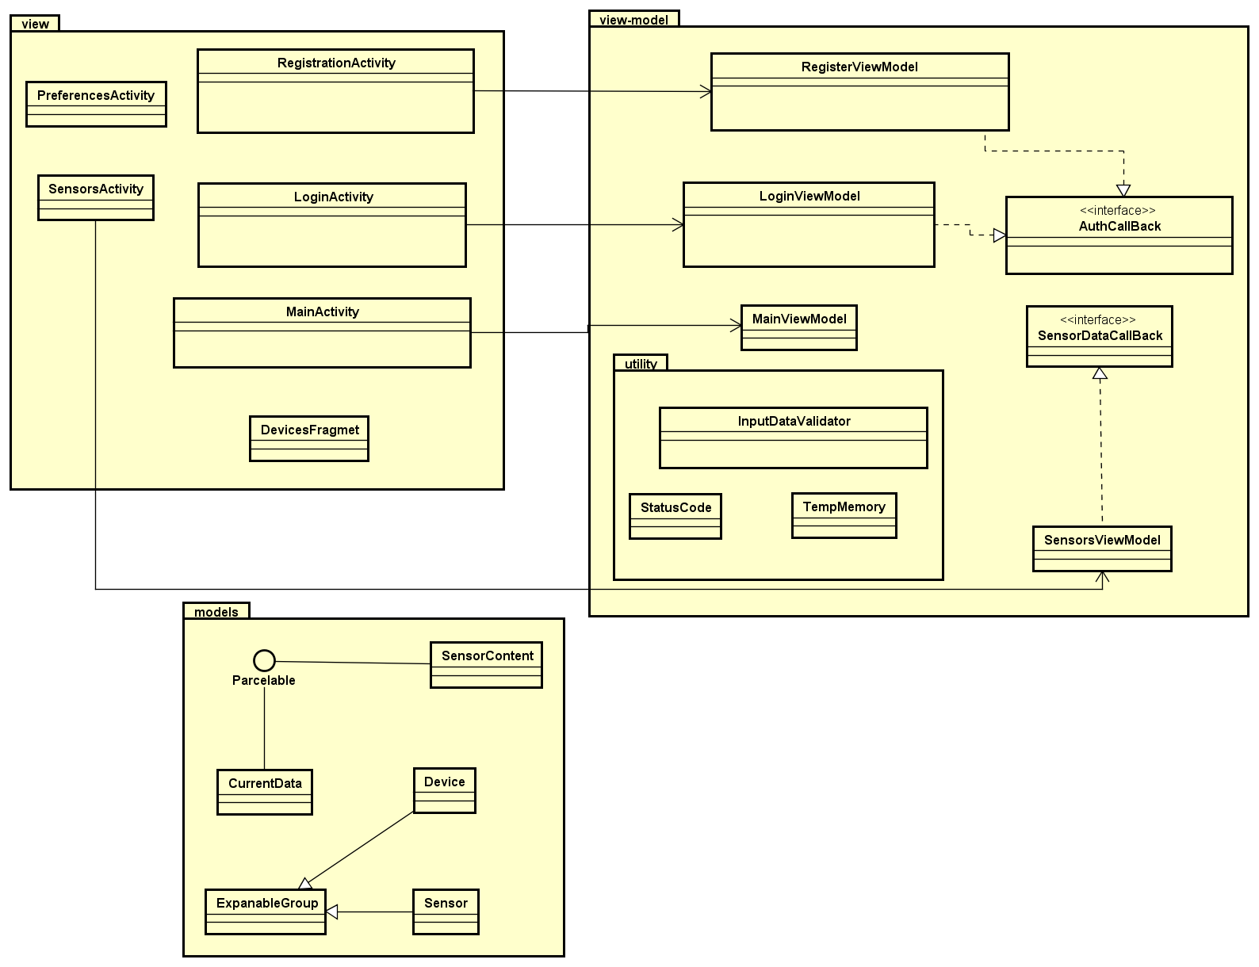

Full class diagram with methods can be found in the Appendix -------

**Retrofit**

The application is using retrofit as a REST client. The diagram below shows how the connection is established using Retrofit. RetrofitAPI interface has defined http request methods. Request classes are responsible for Retrofit configuration. They are implementing Callback interface to react to response from Retrofit.

